QRSS Events Portal

FAQs for Parents & Independent Students

I'm a parent/carer/guardian/independent student, I've received an event invitation for the first time. How do I sign up/create a QRSS Digital Platform (QRSS Events Portal) account?
Before you create your account, you must first create a Queensland Digital Identity (QDI).

Information on QDI : https://www.qld.gov.au/digital-identity
Video: How to create your Queensland Digital Identity
Create your QDI account: https://www.qld.gov.au/digital-identity/creating-and-strengthening-your-queensland-digital-identity

What is Queensland Digital Identity (QDI)?
QDI (Queensland Digital Identity) is the new digital identity system introduced by the Queensland Government to replace the previous QGov system. It serves as a single access point for logging into various state government online services. You can create a QDI by authenticating your identity using official documents like a driver's license or passport. For more information, please visit the QDI website: https://www.qld.gov.au/digital-identity

I’m a parent and my child attends a non-state school. I do not want a QRSS Digital Platform (QRSS Events Portal) account. How does my child still participate in a QRSS event?
If you do not want to create a QRSS Digital Platform account, your child can still participate in a QRSS event.
You can request a paper form from your school. This may be provided as either:
• a printed hard copy, or
• an electronic PDF form.
Once you have completed the form, return it to your school's School Sport Coordinator or the Sport Officer responsible for the event. They will process your child's event invitation and participation without requiring a QRSS Digital Platform account.

As a first-time user, I used a URL link provided by another user and I can’t see anything when I log in. What’s the problem?
Access to QRSS Digital Platform (Events Portal) is by invitation only. If you are a first-time user and have not received an official invitation email from your child’s School Sport Coordinator or a Sport Officer, it is normal to see a blank page after logging in.
If your child attends a non-state school and the school uses the QRSS Digital Platform (QRSS Events Portal) to manage student participation, the school will send you the invitation when they nominate your child for an event. You must use the link in that invitation email to access your child’s information.
If you require further assistance, contact your child’s School Sport Coordinator in the first instance.

My child is a School of Distance Education (SDE) student but also enrolled in another school which is their base school. What is the invitation process?
Students who have a base school outside of their SDE should contact their base school’s school sport coordinator and express their interest in representing that school. The normal invitation process will be used.
If your child wishes to represent their SDE, please contact the SDE school sport coordinator and the normal invitation process will be used.

I have missed the registration date for an event, and the event hasn’t started yet. Can my child still trial?
Outside of the Digital Platform, you need to contact your child’s school sports coordinator or the sports officer listed in the ‘Bulletin’ section to ask whether your request can be supported. This action is not supported on the Digital Platform.

The principal has rejected my child’s event participation request. How do I appeal it?
You need to raise your appeal directly with the principal outside the QRSS Events Portal. The principal can update their decision within the QRSS Events Portal if they choose to do so.

I’m a non-state school parent or independent student, where do I find the timetable/schedule/program for an event?
- On the ‘Events’ homepage select ‘View event’.
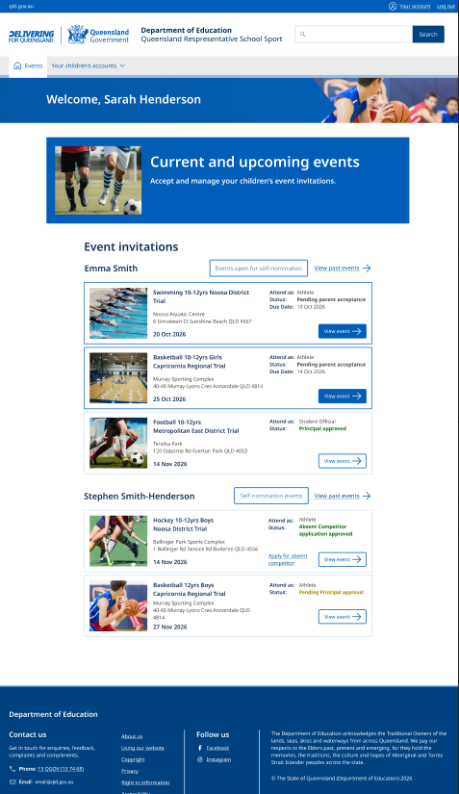
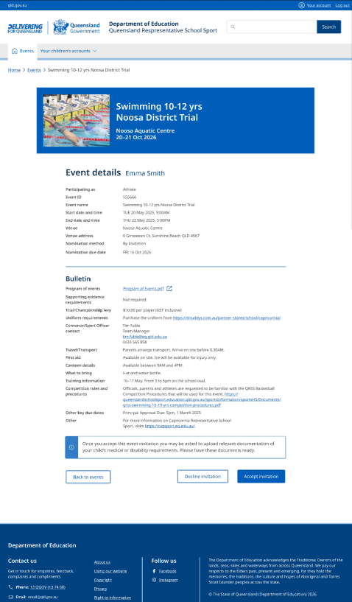
- The timetable/schedule/program will be found under the ‘Bulletin/Team Bulletin’ section.

How do I nominate my child for an event open to self-nomination?
1. Log in portal.
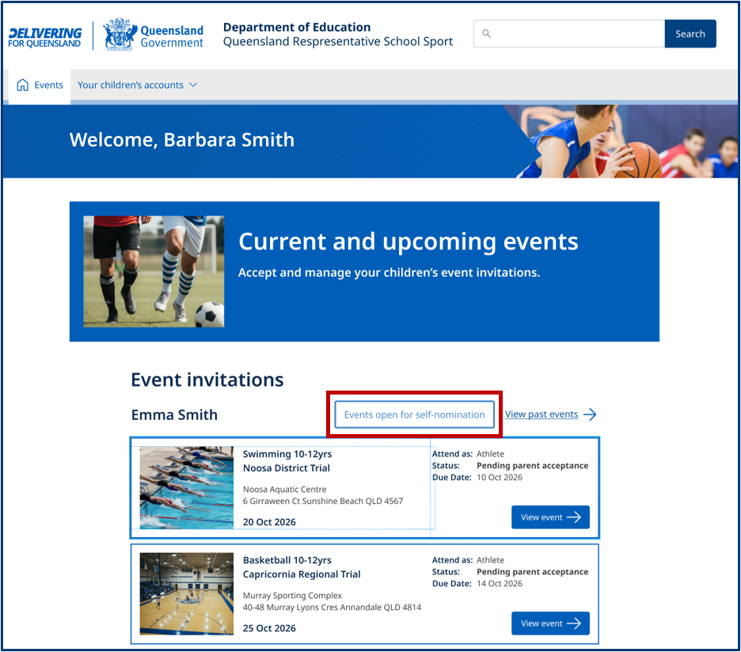
2. On your homepage (“Events” page), select “Events open for self-nomination”.

3. You will arrive at the “Events open for self-nomination page”
4. The upcoming events that are relevant to your child(ren)’s age, gender, district and region, open to parents' self- nomination will be available for you to search and locate.
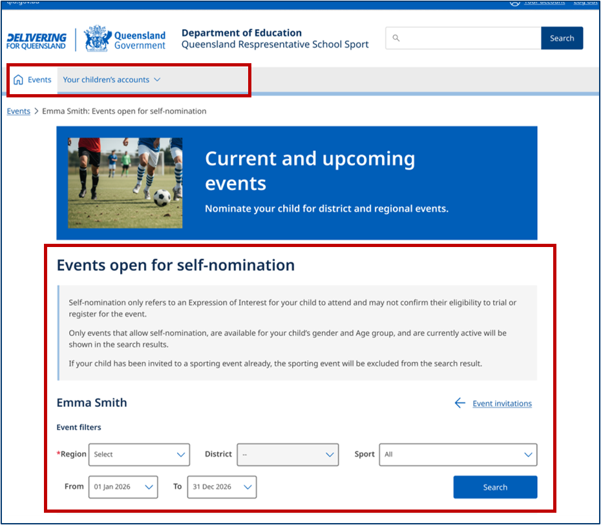
5. Once you’ve located the event you would like to nominate your child for, click “View event.” From there, follow the prompts to complete the self-nomination process.
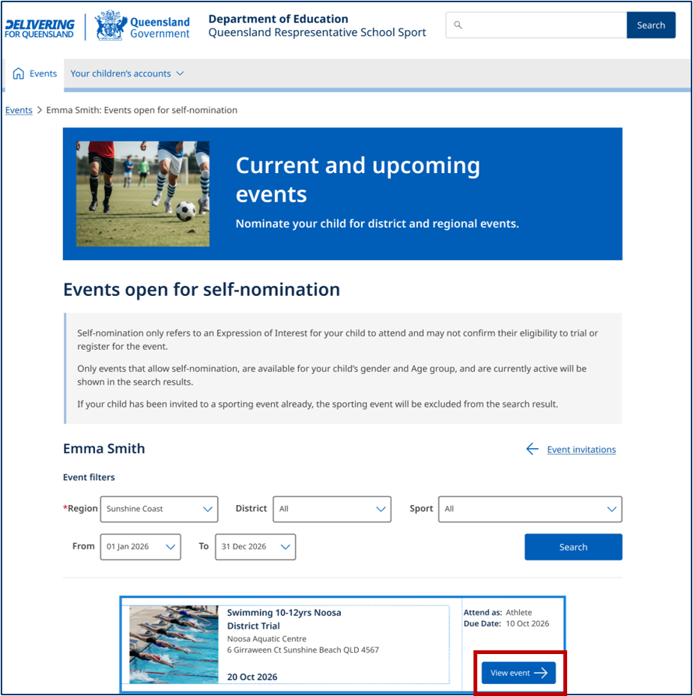
You’ll be notified when your nomination has been approved by your child’s principal and the event organiser

If you can’t find the event in the search—for example, if the nomination deadline has passed or the event is taking place in a different region from where your child resides—please contact your child’s school sport coordinator in the first instance or the relevant district or regional sport officers.

I’m a parent/carer/guardian/independent student, how do I pay for an event?
1. Login to the QRSS Digital Platform (QRSS Events Portal)
2. On Events homepage > Select the event you wish to pay for by selecting ‘View event’
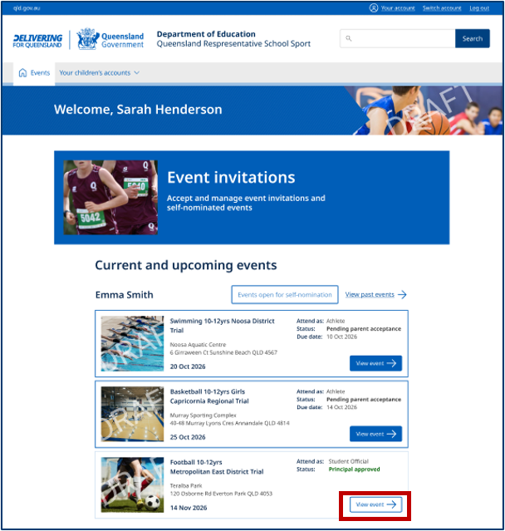
3. This will take you to the ‘Event Details’ & ‘Bulletin’ page
4. Under the ‘Bulletin > Trial/Championship levy’ section you will find instructions on how to make a payment for your event.
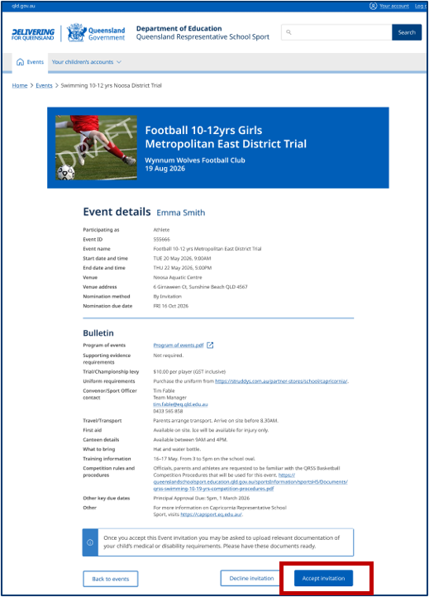

5. If you have further questions, contact your school sport coordinator or the Convenor/Sport Officer in charge of the event.

My child is unable to attend a trial or championship and would like to apply to be an Absent Competitor, what is the process?
1. Outside of the platform (QRSS Events Portal), contact the team official or School Sport Coordinator. For a district trial, it may be your child’s school sport coordinator/PE teacher or for some regional trials or state championships, it may be your child’s team manager, coach or event convenor.
2. Depending on your circumstance, you may want to apply for Absent Competitor; and if so, you can:
a. Login to Digital Platform.
b. Select the event by clicking ‘View event’. Please note that the ‘Status’ must be ‘Principal approved’ to apply for absent competitor.
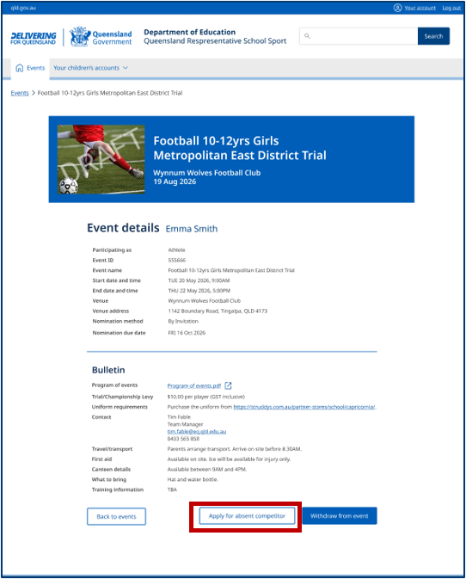
c. Underneath Event detail & Bulletin section you will find the ‘Apply for Absent Competitor’ (note the process may require you to upload supporting evidence to support the absent competitor consideration).

Please note: All absent competitor applications must be submitted prior to the event commencing. No applications will be accepted after the commencement of the event.
If you would like to apply for absent competitor but are unable to do so in the digital platform (QRSS Events Portal), please follow the paper form process. This form, once completed, will need to be submitted for approval to the hosting district/regions sports officer.

Where can I find the information about an event that I have provided permission for my child to participate in?
- Login to the Digital Platform (QRSS Events Portal)
- In the ‘Events’ homepage select the event by clicking ‘View event’
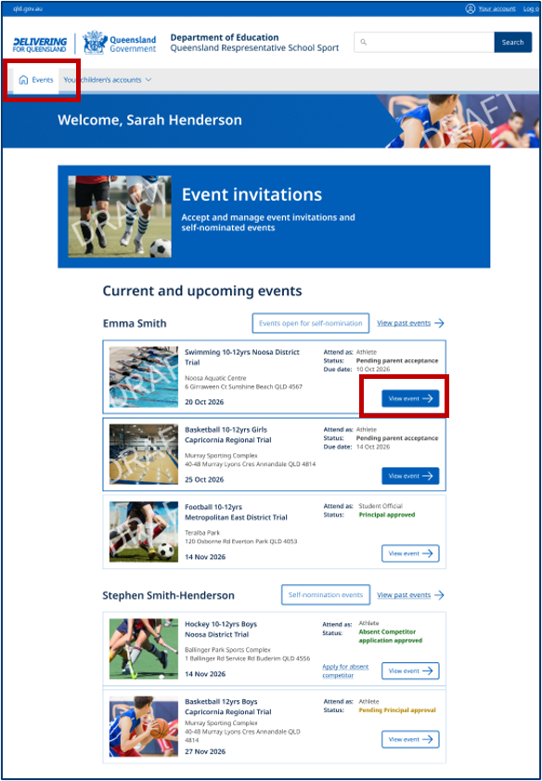
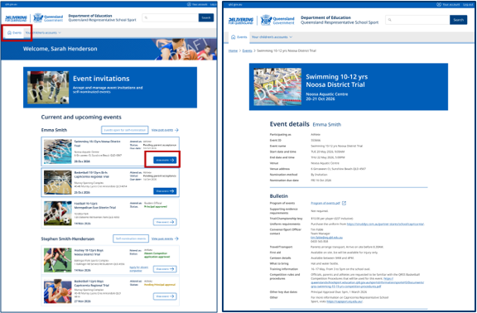
- Event information will be found under ‘Event Details’ or ‘Bulletin’ sections.

How do I find information about a past event that my child has participated in?
- Login to Digital Platform
- If the event has concluded you will find this information under ‘View past events’ If the event is still active it will be on your ‘Events’ homepage. Select the event by clicking ‘View event’.

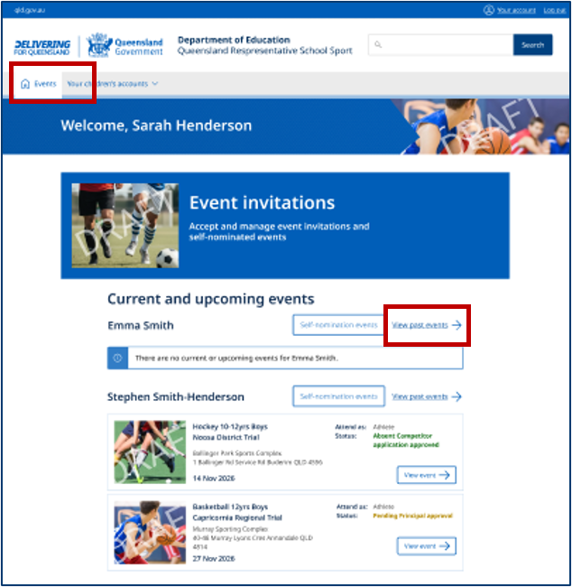

How do I edit/update my own personal details/account?
You can view and edit your details at any time by clicking ‘Your account’ which is found in the top right-hand corner of the page > then select ‘Edit’.
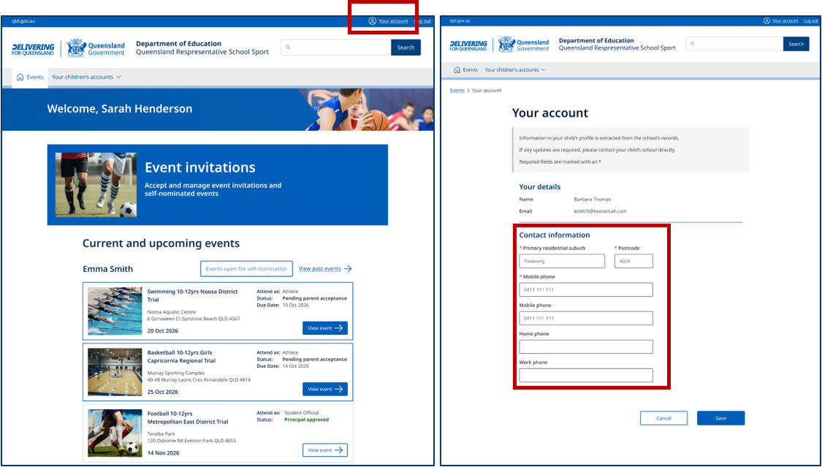
You can edit: ‘Primary residential suburb’, ‘Postcode’, ‘Mobile phone’, ‘Home phone’, ‘Work phone’.
Your name and your email address cannot be edited on the portal. These changes must be actioned by your child’s school, and this request must be made outside the portal.

Can I edit my child’s personal details?
Please refer to the table below on what you can or cannot edit on your child’s profile page:
Section | Field | Editable (Y/N)
Details | Child name (first, middle, last), Your relationship (to child), Date of birth, Gender, School  Contact your school sport coordinator to edit. | No
Details | Indigenous status, English as an additional language or dialect, Dietary requirements | Yes
Emergency contact | First name, last name, Mobile number, email address | Yes

Media, medication, and health information can only be updated within a specific event, not directly in the child’s profile. To edit any previously submitted details or responses, you’ll need to select the relevant event and update the information there. Changes can be made at any time up to the day of the event.

Can I add another one of my children to the platform?
No.
Only children who are eligible to participate in a QRSS event and have been invited to an event by their school’s School Sport Coordinator or a Sport Officer will be linked to your account.

There are multiple parents/carers/guardians (parents) linked to a child’s account. Can all parents accept and update an event invitation submission?
All parents who have been verified as the child’s parent in the digital platform can accept or update a consent submission. However, once the first parent accepts the invitation, only that parent can make changes.
The other verified parent will have read-only access for that event. If the second parent requires a change to be made after the initial invitation has been submitted and the first parent is unwilling to make this change, they will need to contact their child’s school to request this to be edited.
The school principal will review the request and make a decision. If the decision is made to change the original submission, only the principal can action this change.

