QRSS Events Portal

FAQs for Non-State School Principals, Principal Delegates and Admin

As a principal/principal delegate, what do I need to consider when validating the child/parent relationship?
When validating a child/parent relationship you must ensure the person requesting parental rights in the QRSS Digital Platform can exercise 'parent responsibility' and there are no court orders or legal documents that state otherwise. Parent responsibility is clearly defined in the ‘Education (General Provisions) Act 2006’.

I need to fail a parent/child relationship, what is the process?
If the parent does not have the authority to access student data or provide permission, in your ‘Manage Student Approvals’ page, select ‘Principal Rejected’ in the ‘Action’ column and select ‘Parent and child relationship is invalid’. The student will automatically be detached from the parent’s account.

Who is responsible to check that there is a valid parent/child relationship when the paperwork is submitted via paper process?
QRSS Sport Officer/Official
Any sport officer or official uploading a paper copy - parent invitation to the QRSS Events Portal must confirm with the school principal that the relationship is valid before uploading.

School staff
School based roles such as school sport coordinator, school account admin and principal/delegate should confirm the relationship is valid by checking their school’s records before verifying any parent/child relationship.

I need to change an athlete/student official’s principal approval? What is the process?
- You must have the “Principal” or “Principal Delegate” platform role within the relevant school.
- From the left-hand navigation bar, select “Principal > Approvals.”
- Click “View Past Approvals”
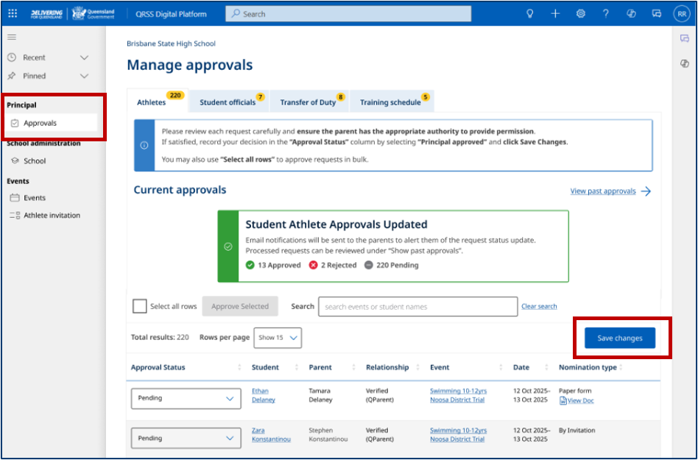
- You should now be on the “Manage approvals > Past approvals” page.
- Use the “Search” function to locate the student.
- Under the “Approval status” column, select the new approval status from the drop-down menu.
- Click “Save changes.”

The parent and event organisers will receive a notification and see the updates.
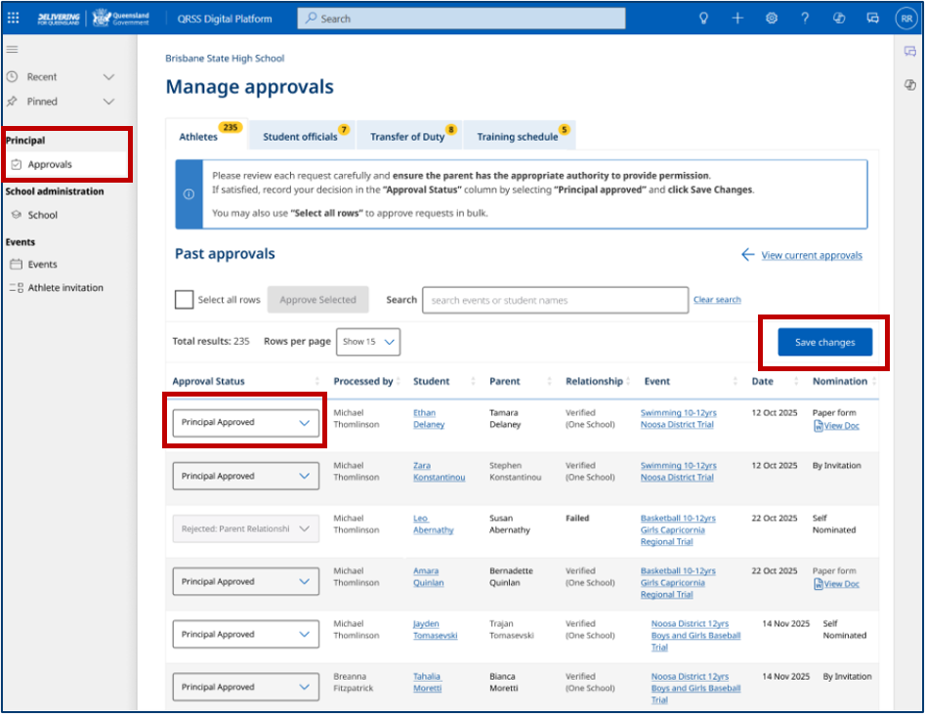

How do I manage and assign QRSS staff roles for my school on the Digital Platform (QRSS Events Portal)? These QRSS roles include principal delegate, school account admin and school sport coordinator.
As a principal and/or principal delegates you have access to Manage staff from your homepage.
In this section you can:
- Add new staff members
- View and edit staff details
- Assign staff to one or more roles in the QRSS Events Portal
- Tag students who are no longer enrolled at your school as “inactive”.

Note: Principals and School Admins may add and edit any staff roles. Principal delegates may not add or edit Principals or other Principal delegates but can add/edit all other roles.

In QRSS Digital Platform (QRSS Events Portal)
• “Active staff” are staff who are currently working at your school
• “Inactive staff” are school staff who have previously held a QRSS role at your school.

Note: QRSS Digital Platform staff records are maintained separately to other staff records. Care should be taken to ensure staff details are kept up to date.

Manage Staff landing page
The landing page contains a table of current and past staff who participate in QRSS events.
The table contains:
• Staff member’s name
• Year level (for SSCs)
• Indication of which roles a staff member has within QRSS Events Portal.
You can use the search field to filter the table rows to find individual staff members.
Staff members can have any combination of roles within the Events Portal. For example, at a smaller school a Principal may also act as School Sport Coordinator, or a staff member may only occasionally serve as a Transfer of Duty Event Official, and so only be assigned the Transfer of Duty role.

Adding staff members
To add a new staff member, press “add staff member” at the top-right of the table and enter:
- Their first name
- Last name
- QDI/MyID email, which allows the staff member to login with their Digital Identity.
This must be the same as the email the staff member users in their Digital Identity credentials, either the Queensland Government QDI or myID.

I have a team/event official that works at multiple schools and I’m their base school principal. Who approves their Transfer of Duty (ToD)?
In the QRSS Events Portal, the official’s base school principal/supervisor is the designated approver for the Transfer of Duty (ToD).
If the event occurs on a day the official is rostered to work at another school, it is your responsibility (base school principal) to notify the principal of that school.

I am a principal/delegate, and want to know what the process is if a staff member, whose transfer of duty has been approved, moves to another school before the event starts?
As the principal/delegate you must manually update the approved ToD in the QRSS Events Portal, which includes an option to reject the approved ToD and provide the reason ‘No longer at school’.

I am a Principal and want to add a Principal Delegate. What do I need to consider and what is the process?

A principal can delegate their roles and responsibilities to any staff member. As well as providing or declining permission to participate in events. A principal or their delegate must also be able to verify parent – child relationships. Certain staff members may not have access to privileged and or confidential information, so keep this in mind when delegating your responsibilities.
Principal delegates must also have permission to grant ToD approval, so therefore must have permission to approve leave from the staff members current role to take on the QRSS role.

