QRSS Events Portal

FAQs for Non-State School – School Sport Coordinators

When an invitation is sent to a first-time user on the QRSS Events Portal (parents or non-Department of Education staff), which email does the invitation need to be sent to?
The invitation must be sent to the user’s QDI/myID email.
If it is sent to a different email, the identity provider will not be able to verify the user and therefore access will not be granted.

Who is responsible to check that there is a valid parent/child relationship when the paperwork is submitted via paper process?
QRSS Sport Officer/Official
Any sport officer or official uploading a paper copy parent invitation to the QRSS Events Portal must confirm with the school principal that the relationship is valid before uploading.

School staff
School based roles such as school sport coordinator, school account admin and principal/delegate should confirm the relationship is valid by checking your school’s database before verifying any parent/child relationship.

What is the process if there is a change in the event details or bulletin, and a parent from my school has submitted an athlete invitation via paper form?

This is a manual process performed outside of the Events Portal. You will need to need to contact the parents, share the change, reconfirm the acceptance and update the status in the platform if required.

If the change is last minute due to weather or similar, then the Event Convenor/Team Official should also attempt to notify parents of the change

I am a Non-State School, School Sport Coordinator, Principal, Principal Delegate, School Account Admin or Team/Event Official and work at multiple non-state schools. Which email do I use for the QRSS Events Portal?
To access the QRSS Events Portal, you need to use the same email address as you used for QDI/myID identity verification. If you try to login using a different email you will not be able to access the portal.

My Year 12 students are finishing, what is required of me?
Before the beginning of each school year, you should go to the ‘Manage students’ menu. Select all Year 12 students from the previous year, as well as any other student/s who have left the school and make them inactive.
This will unlink the student from your school.

Can I update the emergency contact details for a student provided by the parent?
Yes. Once the parent completes their first time onboarding and have added the emergency contact details for the student, then you can update by clicking on the child’s name and selecting ‘edit’.

If the parent has selected ‘Use details as emergency contact’ those fields will be locked. You can change the fields in the Parent/Carer section and then this will be reflected in the ‘Emergency contact’ fields.

If the emergency contact needs to be changed to another person, unselect ‘Use details as emergency contact’ and then update the now empty fields under ‘Emergency contact’.

I'm a School Sport Coordinator in 'Manage nominations' page and I can't send an invitation, what's wrong?
Please check that the parent/child relationship has been verified. An invitation cannot be sent if the parent/child relationship is not verified. Once the relationship has a valid verified status, the invitation can then be sent.

The following relationship status’ do not allow an invitation to be sent: Pending, Failed,
The following relationship status’ do allow an invitation to be sent: Verified, Independent student.
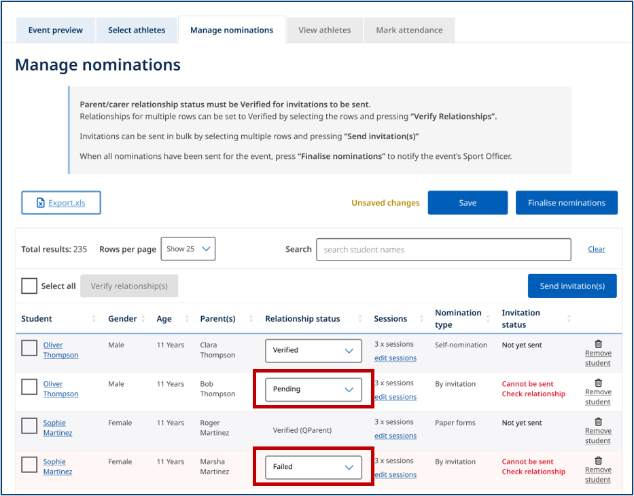

A parent does not wish to create an QRSS Events Portal account. How does the child still participate in a QRSS event?
If they do not want to create a QRSS Events Portal account, the child can still participate in a QRSS event.
They can request a paper form from their school or Sport Officer. This may be provided as either:
• a printed hard copy, or
• an electronic PDF form.
Once they have completed the form, return it to their school's School Sport Coordinator or the Sport Officer responsible for the event.
They will process the child's event invitation and participation without requiring a QRSS Events Portal account.

I have a student wishing to attend an event in which their session within the event does not commence at the Entry Level Event (e.g. Pole Vault – State Champs for Track & Field). What is the process?

Contact the Sport Officer in charge of the event. A Sport Officer can add a student and send an event invitation at any level of event.

I’d like to perform a Bulk upload of student data to create multiple student contacts. What is the process?
- On the SSC homepage select ‘Manage Students’ > ‘Import Students’
- A prompt will appear. Download the file from your device.
- Once file is downloaded, then select ‘Next’
- Once file has uploaded into the QRSS Events Portal you will see your students in ‘My Active Students’.

